# Stock Market Analysis

## Prepared by Doug Finck

Purpose of this document is to provide a screen shot for each worksheet from the Multiple_Year_Stock_data workbook. Please review the following screen shots to confirm that I have successfully completed all 3 sections (Easy, Moderate, and Hard) as described in the homework instructions.

Please refer to the file, “VBA_Homework_Assignment2_DF.bas” submitted with this document for the specific solution used to generate the outcome below.

### Year 2016

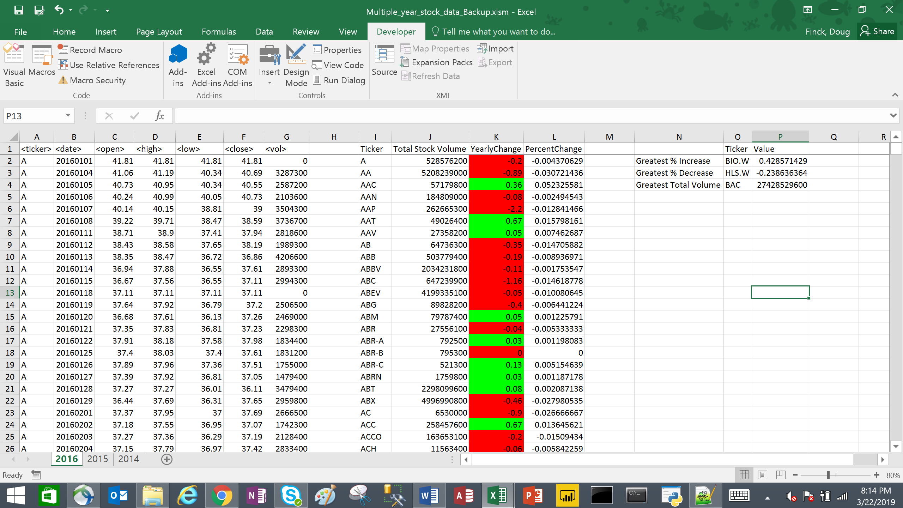

### Year 2015

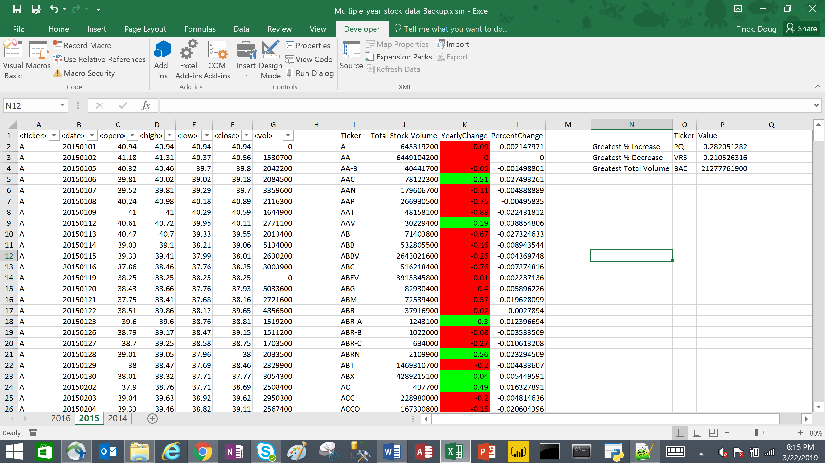

### Year 2014

